Please return this document to Jennifer Reed, Jennifer.reed@semanticbits.com, or Paul Baumgartner, Paul.baumgartner@semanticbits.com

Enter the tester information in the first table. Capture the version number needs in each of the individual tests since we may be releasing periodic updates.

Tester Information

Name | Sarah Hahne
Test date | 9/8/08
Computer OS
Computer browser version | IE7
Program
Program Version | caAERS v 1.3
Program URL | Hosted demo, https://sbdev1000.semanticbits.com:18031/caaers/public/login  or a properly installed local version of 1.3

User Story | Select a different report than suggested
Scenario Description | Open a patient/study combination and add multiple Treatment AEs for the patient.
caAERS Version | (v1.3, v1.3.1, v 1.3.2, etc)
Behaved as expected? | no
General Comments (what you liked, what you didn’t like)
Specific Issues (bugs) | - The link to a patient’s study calendar brought up a ‘page not found’ window.  - After entering AE information and clicking ‘Save and Continue.’ I received an error message. See below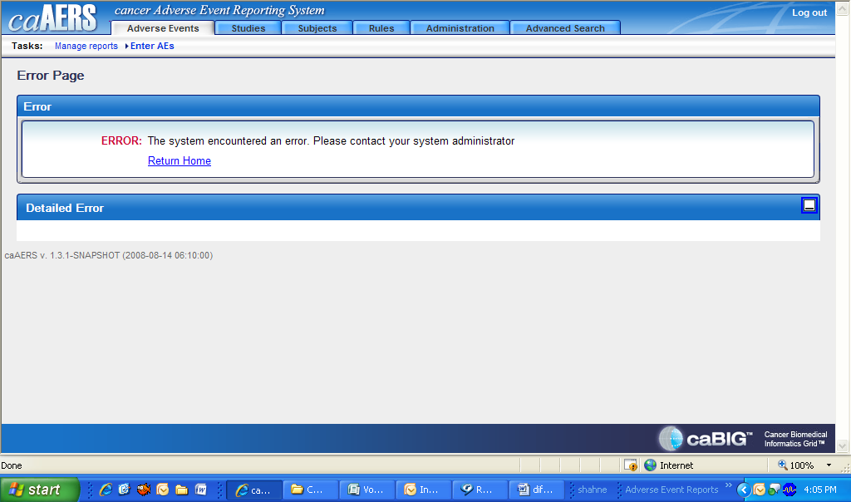  - For patient, Chris P Cream, I entered information for all fields and clicked ‘save.’ The error message I then received is below: 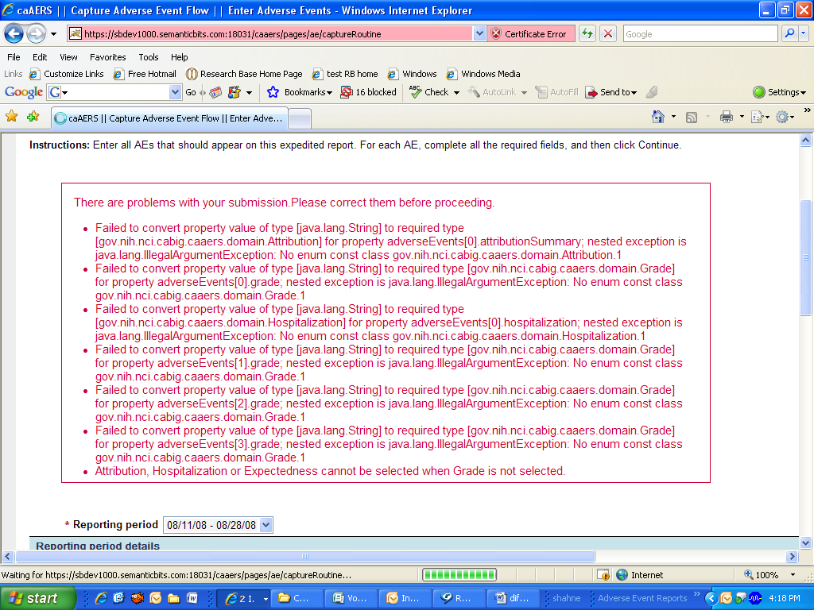
Issues to raise (improvements)

